# Section 1: Let's Dive In!

## How to Get Help

## Join Our Community!

## Course Resources

## Let's Build an App!

## Critical Questions

## Quiz 1: Core Concepts

## A Few More Critical Questions

## Node Setup

npx create-react-app <project name>

npx create-react-app jsx

cd jsx

npm start

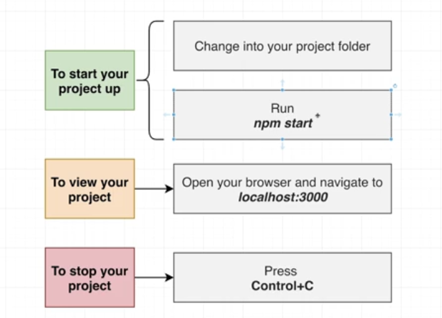

## What is Create React App?

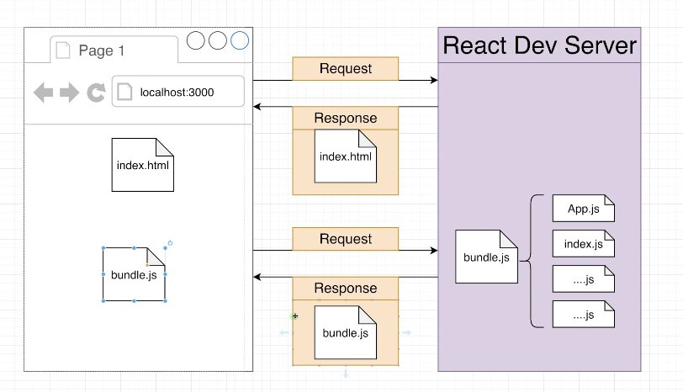 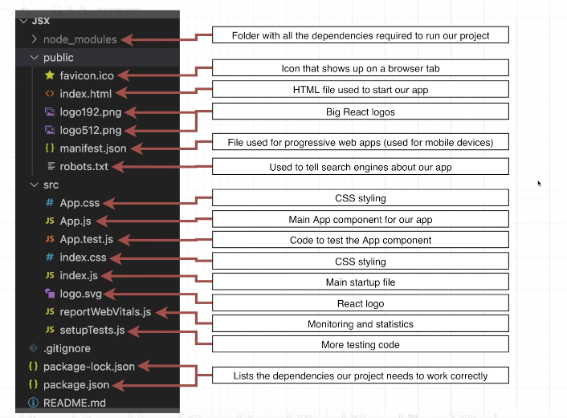 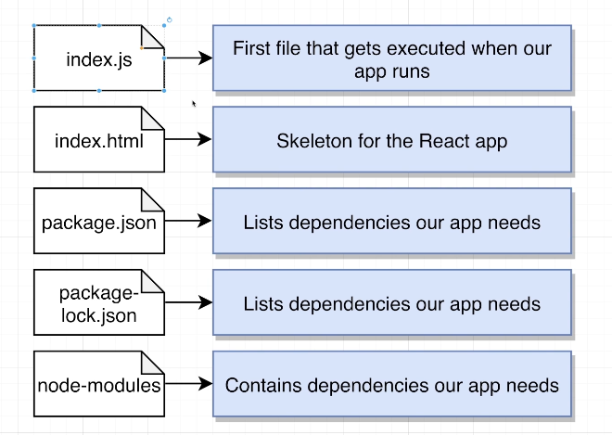

# Section 2: Creating Content with JSX

## Showing Basic Content

// 1) Import the React and ReactDOM libraries

import React from 'react';

import ReactDOM from 'react-dom/client';

// 2) Get a reference to the div with ID root

const el = document.getElementById('root');

// 3) Tell React to take control of that element

const root = ReactDOM.createRoot(el);

// 4) Create a component

function App() {

  return <h1>Hi there!</h1>;

}

// 5) Show the component on the screen

root.render(<App />);

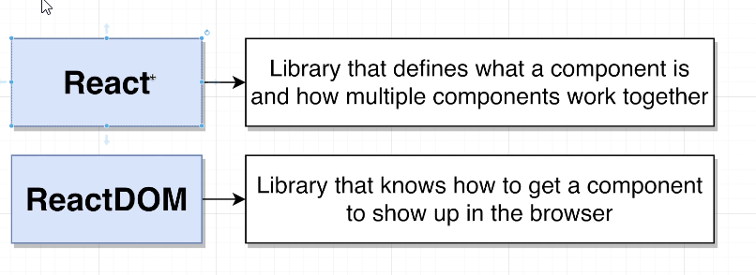

## What is JSX?

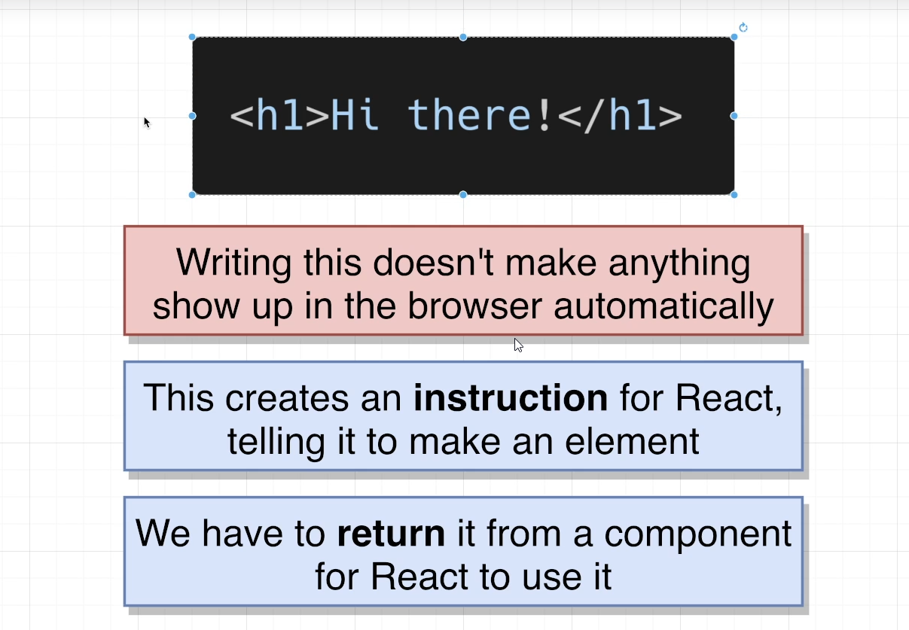

## Printing JavaScript Variables in JSX

1. function App() {
2. let message = 'Bye there';
3. if(Math.random() > 0.5) {
4. message = 'Hello there!';
5. }
6. return <h1>{message}</h1>;
7. }

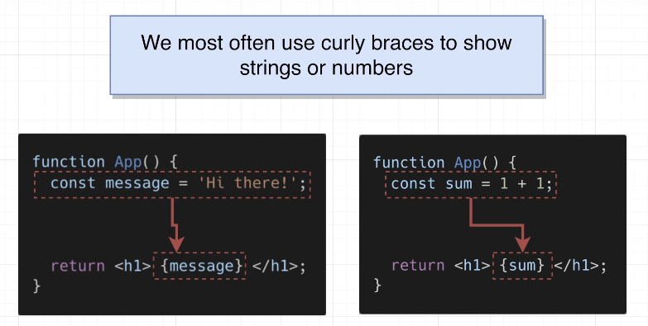 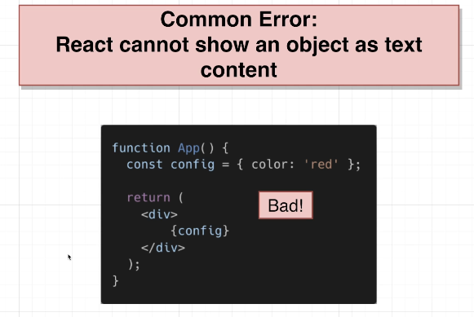

## Shorthand JS Expressions